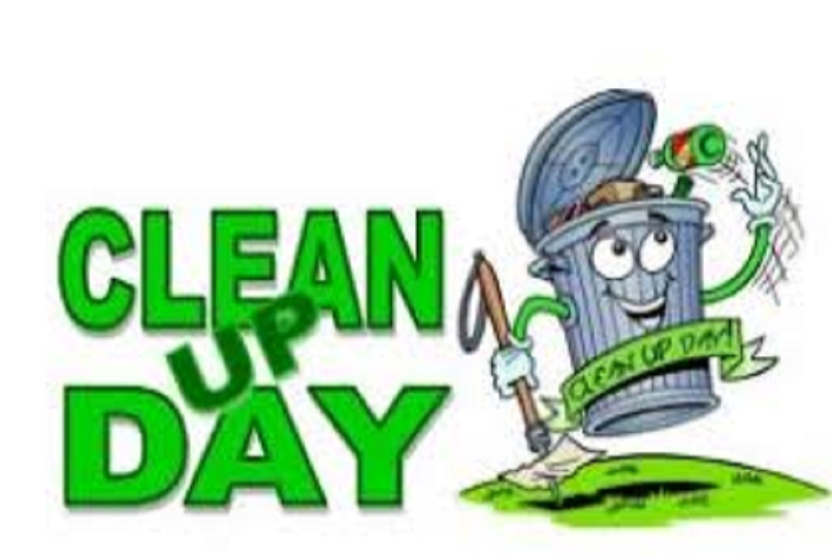
Fall Cleanup days are scheduled for September 17-19. This is the time to do some Fall Cleaning and get rid of broken or unused items cluttering up your house, garage, or yard. This is limited to residents and businesses of Gilmore City. Let’s take this opportunity to make our places look great, which in turn makes our town look fabulous! Every TV will need a tag. TV’s will be $15 each. Appliances will be free and will not need a sticker. You can either pay upfront or we can add it to your city account. If there is something you are in question about, please call City Hall. Anything in question will be left and not picked up due to safety concerns. Garbage and unneeded/wanted junk can be disposed of during this time except for the items below. NO Refrigerators, Freezers or Coolers full of food or we will not pick it up. Carpet must be rolled up and preferably on a pallet. If you do not have access to a pallet, please let us know. One free bucket load per resident, and $20 per bucket-load thereafter. If you cannot get into city hall to get a tag for a tv and there is one on your property whether you put it there or not it will get charged to you. DO NOT drop off your extra loads in the roll offs as we will watch camera footage and you will be charged. All items must be placed at the curb by Wednesday morning at 8 a.m. and once they get through all of town on Wednesday/Thursday. If you have more to be picked up, items must be out by 8 a.m. Friday morning. If you have any questions, please contact City Hall. Here is a list of items that we can or cannot take.

Items we can’t collect:
Paint/Chemicals, Batteries, Tires, Asbestos, Hazardous liquid, or medical waste, Oil, Items containing mercury, Yard waste.

Items we can collect:
Computer’s/Laptops, Humidifier/Dehumidifier, TV’s, Water Heaters, Refrigerators, Furnaces, Freezers, Water Softeners, Stoves, Water Coolers, Dishwashers, Generators, Washer/Dryer, Air Compressors.

