Please join us for the 2020 Gilmore City
The parade will begin at 10:30 a.m. Parade line up starts at 9 a.m. East of the school on SE 4th St. by the Quonsets. Parade route will begin there and follow SE G Ave, then north through SE 2nd St, over to SE D Ave and turn onto S. Gilmore St (Main St) where the parade will end by the First Lutheran Church.

Entry forms need to be completed and brought back to City Hall or emailed to: cityhall@gilmorecityiowa.com
Fun Days Parade on Saturday, August 29th!

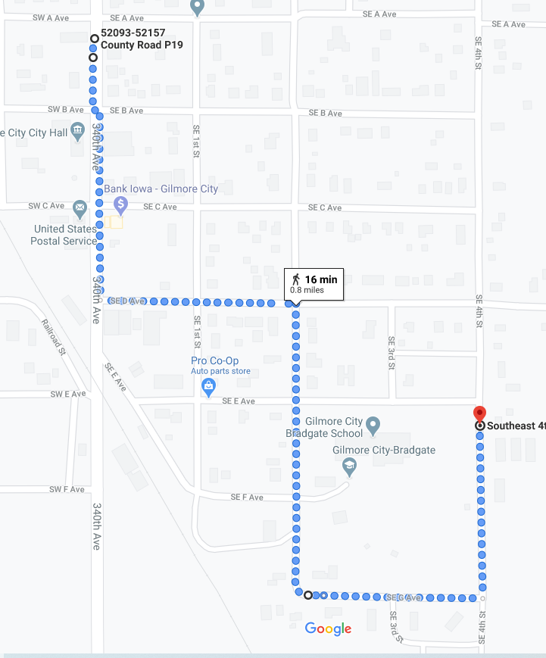
Gilmore City Fun Days Parade Entry Form
NAME: ________________________________________________________________

ENTRY: _______________________________________________________________

ADDRESS: ____________________________________________________________

PHONE/EMAIL: ________________________________________________________

ENTRY DESCRIPTION (FOR RADIO STATION) _______________________________
______________________________________________________________________

